Brenton Chapter
Knights of Rose Croix
Ancient Accepted Scottish Rite
Valley of Canton
Invites You To Attend

FEAST OF THE PASCHAL LAMB

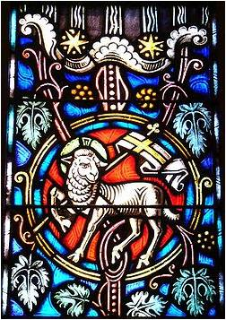

Brenton Chapter Knights of Rose Croix Valley of Canton invites you to attend The Feast of the Paschal Lamb on Friday, March 16, 2018 at 6:30 PM at the Canton Masonic Temple. This event is open to the public.

Dinner will be at 6:30 PM followed by the service. RESERVATIONS ARE REQUIRED FOR THE DINNER and can be made by calling 330-455-2321 or email valleyofcanton78@gmail.com

The Feast of the Paschal Lamb is Maundy Memorial Service honoring those Brethren who have been called to eternal refreshment in paradise of God during the past year.

This non-sectarian service will be conducted by Valley of Canton’s Brenton Chapter of Rose Croix with Most Worshipful Brother Easterling, Jr. Grand Master of Masons in Ohio as the featured Speaker.

Friday, March 16, 2018
6:30 PM
Canton Masonic Temple
Canton, Ohio

